**11/12** 

**Contemporary Philippine Arts from the Regions**

**Quarter 2 – Module 3-4**

**Local Materials and Techniques**

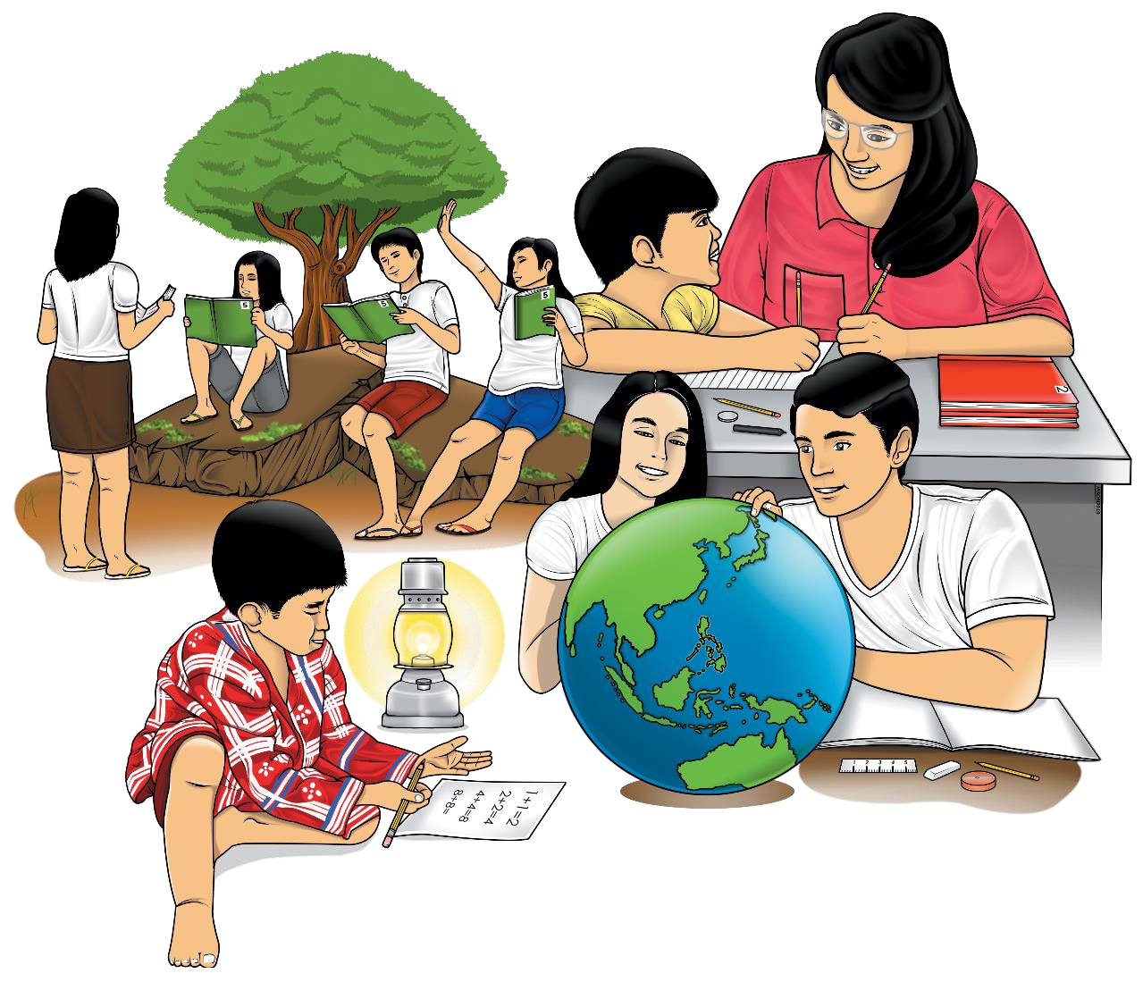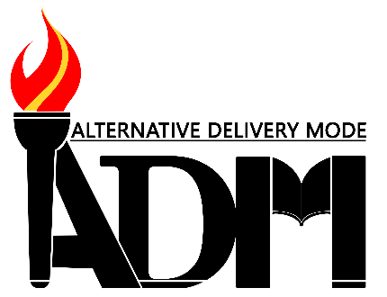

**Contemporary Philippine Arts from the Region – Grade 11/12**

**Alternative Delivery Mode**

**Quarter 2 – Module 3-4: Local Materials and Techniques**

**First Edition, 2020**

**Republic Act 8293, section 176** states that: No copyright shall subsist in any work of the Government of the Philippines. However, prior approval of the government agency or office wherein the work is created shall be necessary for exploitation of such work for profit. Such agency or office may, among other things, impose as a condition the payment of royalties.

Borrowed materials (i.e., songs, stories, poems, pictures, photos, brand names, trademarks, etc.) included in this module are owned by their respective copyright holders. Every effort has been exerted to locate and seek permission to use these materials from their respective copyright owners. The publisher and authors do not represent nor claim ownership over them.

Published by the Department of Education, Tagbilaran City Division

Secretary: SDS Joseph Irwin A. Lagura, Ed.D

Undersecretary: ASDS Marcelo K. Palispis, Ed.D.

|  |
| --- |
| **Development Team of the Module**    **Writer/s:** Faustno Rey T. Hormiguera  Rochelle Margaret C. Real  Dennis L. Bigcas  **Editor/s**: Faustno Rey T. Hormiguera  Rochelle Margaret C. Real  Dennis L. Bigcas  **Reviewers**: Mark Vincent Ranay  Alberto A. Lacang  **Management Team:**  Superintendent Joseph Irwin A. Lagura, PhD  Division CID Chief John Ariel A. Lagura, PhD  Division EPS In charge of LRMS Neolita S. Sarabia, PhD |

**Printed in the Philippines by** Department **of Education – Region VII | Tagbilaran City Division**

Office Address: Rajah Sikatuna, Dampas District, Tagbilaran City Bohol, Philippines 6300

Telephone: (038)427-1702; (038)427-2506

E-mail Address: dtagbilarandivision@yahoo.com

# 11/12

**Contemporary Philippine Arts**

**From the Region**

**Quarter 2 – Module 3-4**

**Local Materials and Techniques**

FAIR USE AND CONTENT DISCLAIMER: This SLM (Self Learning Module) is for educational purposes only. Borrowed materials (i.e., songs, stories, poems, pictures, photos, brand names, trademarks, etc.) included in these modules are owned by their respective copyright holders. The publisher and authors do not represent nor claim ownership over them. Sincerest appreciation to those who have made significant contributions to these modules.



**Introductory Message**

For the facilitator:

Welcome to the Contemporary Philippine Arts from Region -11/12 Alternative Delivery Mode (ADM) Module Local Materials and Techniques!

This module was collaboratively designed, developed and reviewed by educators both from public and private institutions to assist you, the teacher or facilitator in helping the learners meet the standards set by the K to 12 Curriculum while overcoming their personal, social, and economic constraints in schooling.

This learning resource hopes to engage the learners into guided and independent learning activities at their own pace and time. Furthermore, this also aims to help learners acquire the needed 21st century skills while taking into consideration their needs and circumstances.

In addition to the material in the main text, you will also see this box in the body of the module:

***Notes to the Teacher***

This contains

helpful tips or strategies

that

will

help you in guiding the learners.



As a facilitator you are expected to orient the learners on how to use this module. You also need to keep track of the learners' progress while allowing them to manage their own learning. Furthermore, you are expected to encourage and assist the learners as they do the tasks included in the module.

For the learner:

Welcome to the Contemporary Philippine Arts from Region-11/12 Alternative Delivery Mode (ADM) Module on **Local Materials and Techniques!**

The hand is one of the most symbolized part of the human body. It is often used to depict skill, action and purpose. Through our hands we may learn, create and accomplish. Hence, the hand in this learning resource signifies that you as a learner is capable and empowered to successfully achieve the relevant competencies and skills at your own pace and time. Your academic success lies in your own hands!

This module was designed to provide you with fun and meaningful opportunities for guided and independent learning at your own pace and time. You will be enabled to process the contents of the learning resource while being an active learner.

This module has the following parts and corresponding icons:

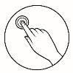***What I Need to Know*** This will give you an idea of the skills or competencies you are expected to learn in the module.

***What I Know*** This part includes an activity that aims to check what you already know about the lesson to take. If you get all the answers correct (100%), you may decide to skip this module.

***What’s In*** This is a brief drill or review to help you link the current lesson with the previous one.

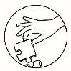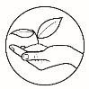

***What’s New*** In this portion, the new lesson will be introduced to you in various ways such as a story, a song, a poem, a problem opener, an activity or a situation.

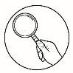***What is It*** This section provides a brief discussion of the lesson. This aims to help you discover and understand new concepts and skills.

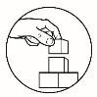***What’s More*** This comprises activities for independent practice to solidify your understanding and skills of the topic. You may check the answers to the exercises using the Answer Key at the end of the module.

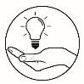***What I Have Learned*** This includes questions or blank sentence/paragraph to be filled in to process what you learned from the lesson.

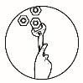***What I Can Do*** This section provides an activity which will help you transfer your new knowledge or skill into real life situations or concerns.

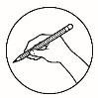***Assessment*** This is a task which aims to evaluate your level of mastery in achieving the learning competency.

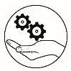***Additional Activities*** In this portion, another activity will be given to you to enrich your knowledge or skill of the lesson learned. This also tends retention of learned concepts.

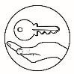***Answer Key*** This contains answers to all activities in the module.

At the end of this module, you will also find:

***References*** This is a list of all sources used in developing

this module.

The following are some reminders in using this module:

1. Use the module with care. Do not put unnecessary mark/s on any part of the module. Use a separate sheet of paper in answering the exercises.
2. Don’t forget to answer *What I Know* before moving on to the other activities included in the module.
3. Read the instruction carefully before doing each task.
4. Observe honesty and integrity in doing the tasks and checking your answers.
5. Finish the task at hand before proceeding to the next.
6. Return this module to your teacher/facilitator once you are through with it.

If you encounter any difficulty in answering the tasks in this module, do not hesitate to consult your teacher or facilitator. Always bear in mind that you are not alone.

We hope that through this material, you will experience meaningful learning and gain deep understanding of the relevant competencies. You can do it!

### What I Need to Know

This module was designed and written with you in mind. It is here to help you describes various contemporary art forms and their practices from the various regions. The scope of this module permits it to be used in many different learning situations. The language used recognizes the diverse vocabulary level of students. The lessons are arranged to follow the standard sequence of the course. But the order in which you read them can be changed to correspond with the textbook you are now using.

Most Essential Learning Competency:

|  |  |
| --- | --- |
| Content  Standards: | Shows understanding of the materials and techniques. |
| Performance standards: | Discriminates among various materials and techniques. |
| Learning  Competencies: | 1. Critiques available materials and appropriate techniques (CAR11/12TPP-0c -e-12); and 2. Justifies the use of materials and the application of techniques (CAR11/12TPP-0c -e-13) |
| Objectives: | 1. Identify local materials in the community and choose techniques to create appropriate artwork; and 2. Present and support the chosen local material & and artwork to be created. |

### What I Know

**Activity 1**

***What to do:***

Below are pictures of art works by different artists. Identify what material/s are used to create each. Check the box if the material/s are available in your community, province or region. Write down your answers in the space provided for.

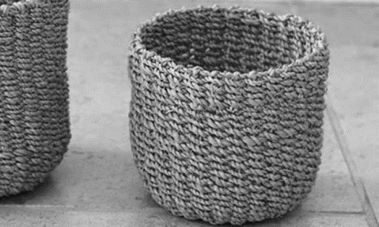

<https://cutt.ly/EhD49WC>

1. Material/s used: ________________________________________

Availability  Locality  Province  Region

Photo courtesy of Canna Luisa Cindrelle Bernas

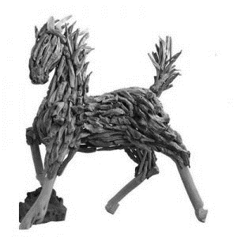<https://cutt.ly/AhD7h3x>

1. Material/s used: _________________________________________

Availability  Locality  Province  Region

Photo courtesy of Canna Luisa Cindrelle Bernas

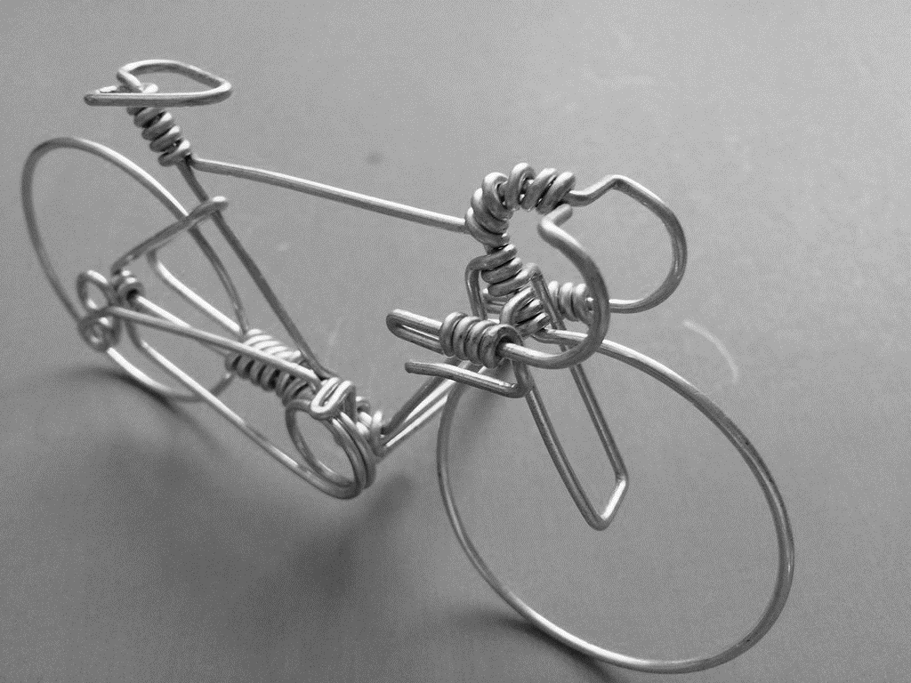

<https://cutt.ly/ghD7BEt>

1. Material/s used: _________________________________________

Availability  Locality  Province  Region

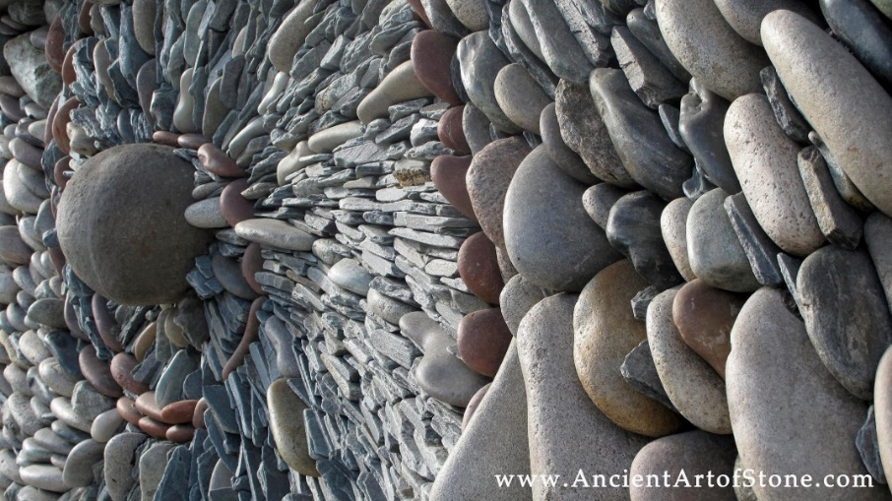

<https://cutt.ly/vhG91PE>

1. Material/s used: _______________________________________

Availability  Locality  Province  Region

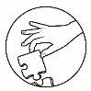

### What’s In

Study the work of art below 'The Fishermen', 1981 | © Ang Kiukok. Understand and interpret it. Answer on the separate sheet provided for.

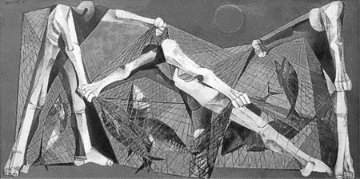

<https://cutt.ly/jhG4eA0>

|  |  |
| --- | --- |
| **Lesson 1** | **Contemporary Art** |



### What’s New

As you have explored in the previous modules, artists have their own way of expressing art using different kinds of mediums/ materials and manner by which materials are processed and transformed. In appreciating art, whether of its creativity and or of its efficient functions, we need our senses. Thus on the process of giving attention to it, we understand or make sense of a work of art; the mediums, techniques and functions are part of the meaning of the work.

#### What is It

These are the factors which determine the viewer/ users experience and response:

**Medium** – are the material used to create an artwork. Artist use medium to express their thought, ideas, feelings, etc.

Mediums and techniques may also differ depending on the inclination of the artists and the place where it originated. Various artworks are inspired by the artist’s locality: its rich resources, culture and practices.

Below are different common materials transformed into unique artworks which became trademarks of the artist or of the locality it originated. But, not limiting yourselves in the common materials usually used, you will find creative and efficient materials which can be used to create different artwork in line with the form of art you as an artist desires to make. It can even be an environmental hazard saver, answer to people’s needs, or a locality’s trademark product for tourist attraction or business. Here are potential materials not commonly and not commonly used:

1. **Abaca** - Initially used as material for rope, and transformed into a wide variety of efficient products. The versatility, durability and availability of abaca, or Manila hemp, makes it easy to work with or create different designs.

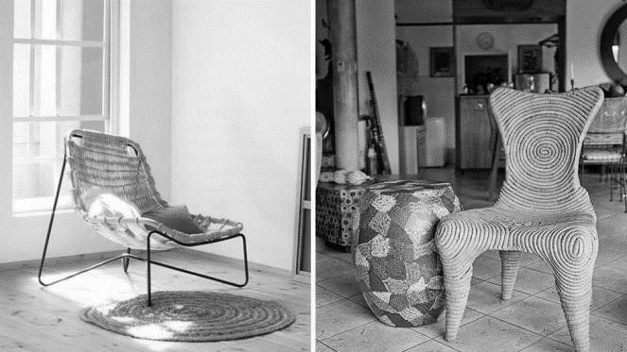

Photo courtesy of Yanko Design & Dairy Darilag (Main Photo), from Real Living Team

1. **Coconut Shells** - Considered equal in quality and appearance to tortoise shells or ivory. It may be used to create a wide array of boxes, lamps, tabletops, chairs, bags, belts, body accessories, and household ornaments.

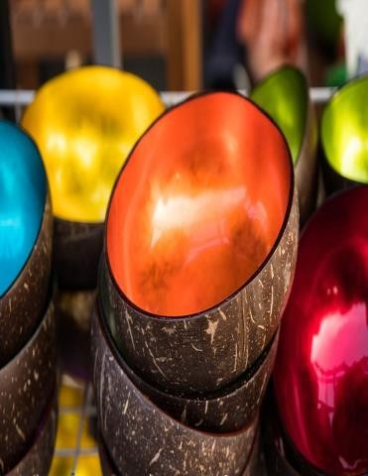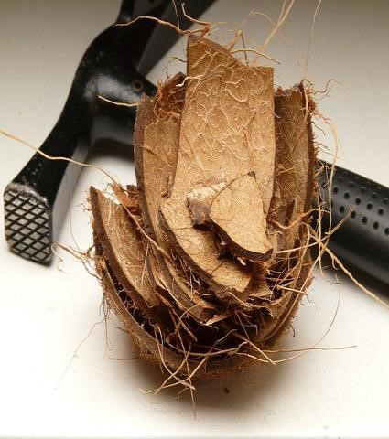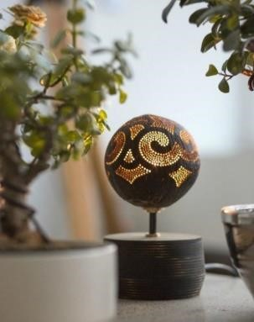

Photo courtesy of

Creative

Commons

Photo courtesy of

Trilogy

Tours,

from

Real

Living

Team

1. **Bamboo**- proved that it's a versatile must-have that designers and homeowners should consider. Aside from being used in different pieces of furniture and house parts, bamboo is also made into musical instruments, and creative decors.

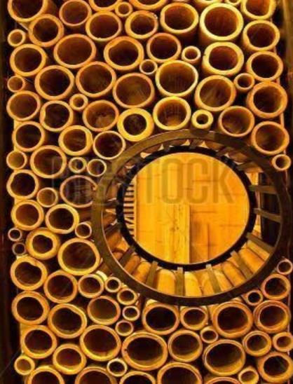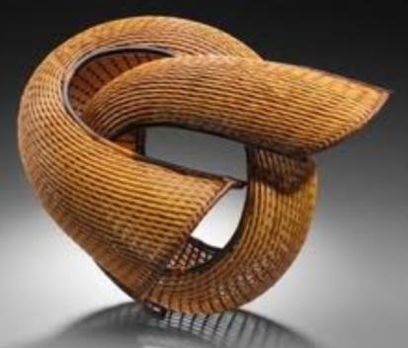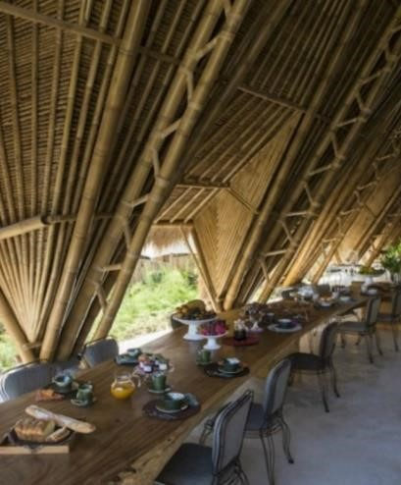

Photo courtesy of Stefano Scatà, from Real Living Team Photo courtesy of Creative Commons

1. 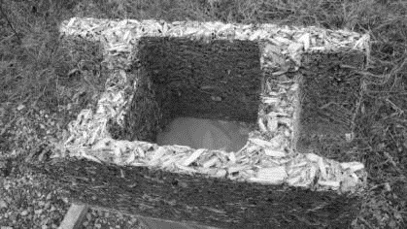**Blocks**- out of rice hulls/ saw dust.

Photo courtesy of Pinterest

1. **Scrap/Cut tiles**– made into decorative walls etc.

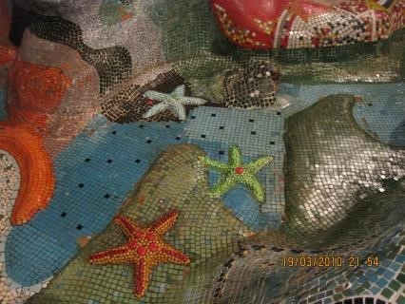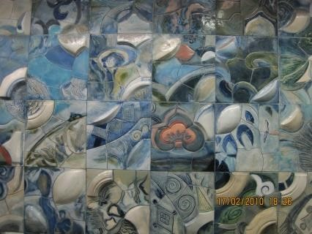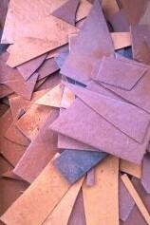

***Tile-istic*** by Canna Luisa Cindrelle Bernas.2013.

Photo courtesy of Canna Luisa Cindrelle Bernas

1. **House cleaning materials (scrubs, rag, strainer)** – made into furniture designs.

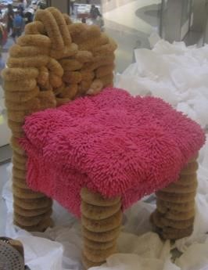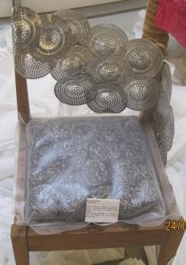

Photo courtesy of

Canna Luisa Cindrelle Bernas

1. **Scrap wood** - made into wall decors, etc.

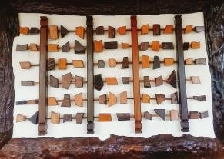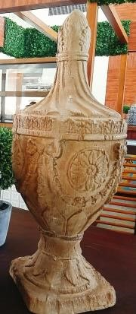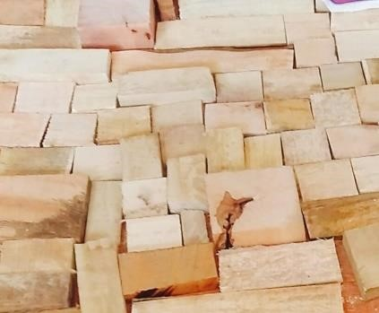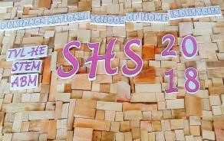

Photo courtesy of Canna Luisa Cindrelle Bernas

#### 8. Beads

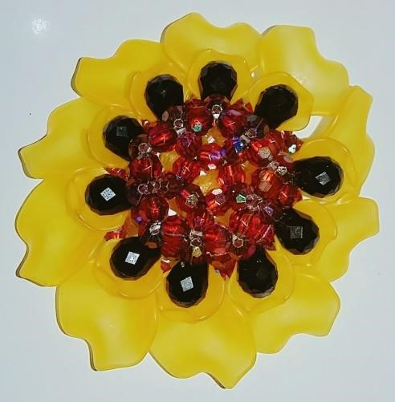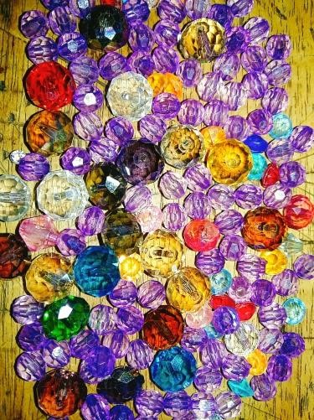

***Beadazzle*** by Canna Luisa Cindrelle Bernas.2013. Photo courtesy of Canna Luisa Cindrelle Bernas Photo courtesy of Artist

#### 9. Paper, corrugated boxes

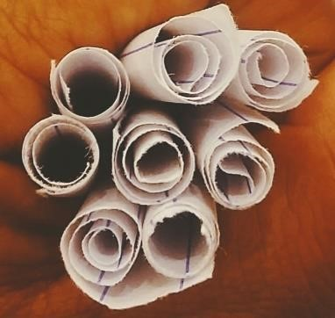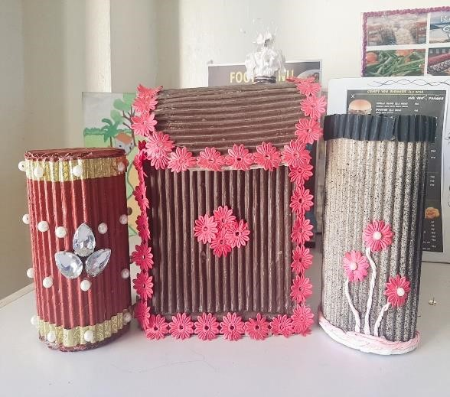

***Draw Lots*** by Canna Luisa Cindrelle Bernas.2013. Photo courtesy of Canna Luisa Cindrelle Bernas

Photo courtesy of Artist

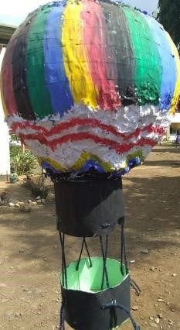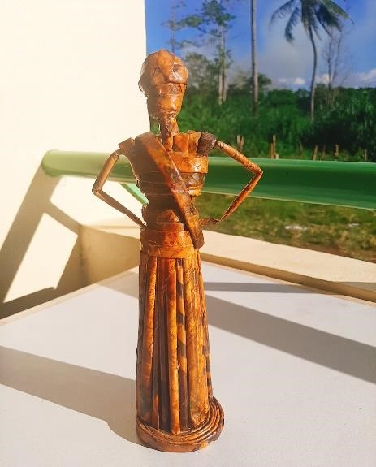

Photo courtesy of Canna Luisa Cindrelle Bernas

#### 10. Metal, tie wires, tin cans

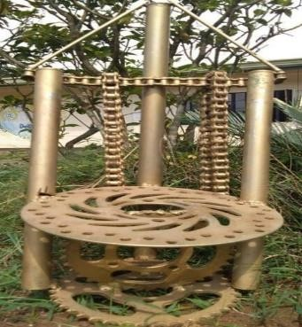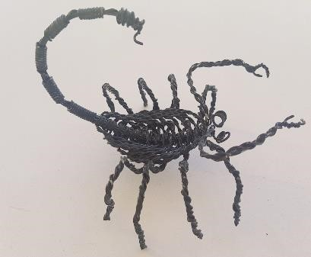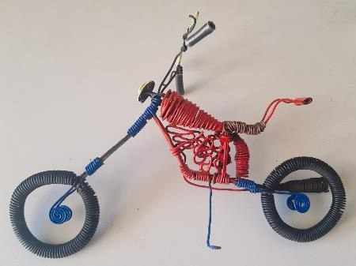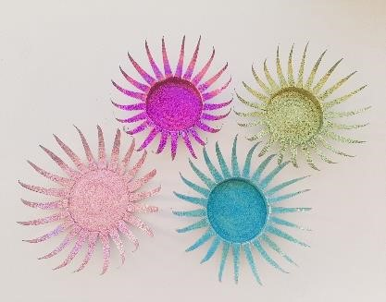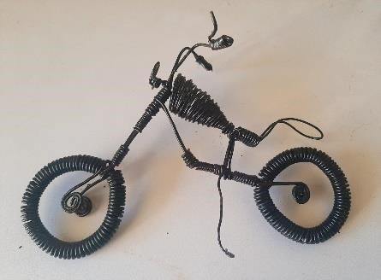

Photo courtesy of Canna Luisa Cindrelle Bernas

#### 11. Empty & recyclable styro and plastic cups/bottles

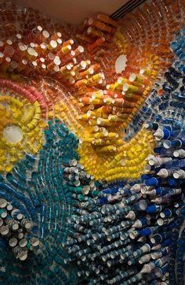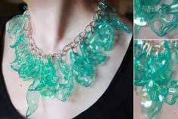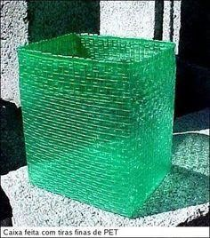

Photo courtesy of

Amber Brink from

Pinterest

Photo courtesy of

wildbamboo.blogspot.com

from Pinterest

Photo courtesy of Nadia Bogari,

Article from mymodernmet.com

from Pinterest

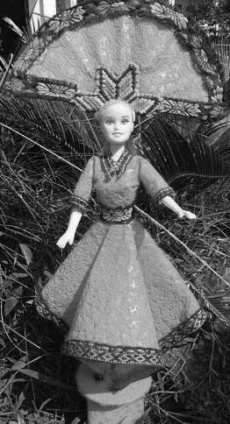

#### 12. Pieces of Cut cloth

Photo courtesy of Canna Luisa Cindrelle Bernas

7

#### 13. Cement, different types of clay or plaster of Paris

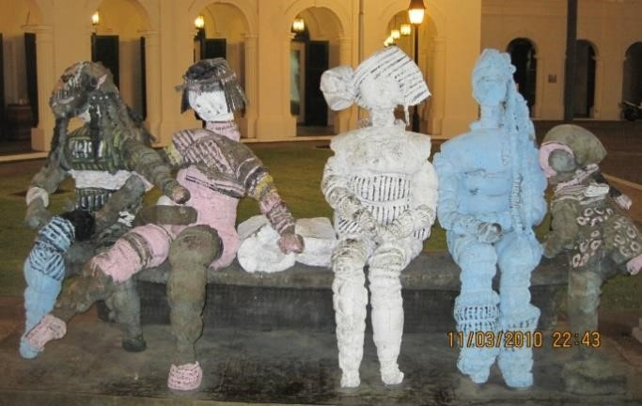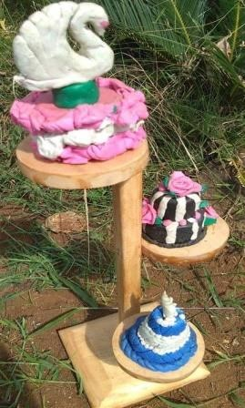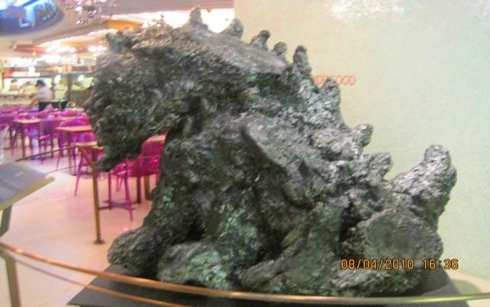

Photo courtesy

Canna Luisa Cindrelle Bernas

Photo courtesy

Canna Luisa

Cindrelle Bernas

Photo courtesy Canna Luisa Cindrelle Bernas

Aside from the above mentioned materials, there is still a wide array of materials which can be used out of creativity and functionality. From sea shells to human skull shells, from leaves and flowers to insect and insect parts, from glass to cotton, and from watercolor, coffee and soil painting to dirty water painting. Way too many choices, you just have to explore your locality for potential materials and innovate a unique and contemporary artwork that you desire to make.

For more ideas you may browse the internet or visit these websites:

https://www.realliving.com.ph/home-improvement/indigenous-materials-for-a-filipinohome-a00043-20180109

https://www.spot.ph/arts-culture/arts-culture-peopleparties/72259/unusual-art-pinoysa1806-20171207-lfrm3

### What’s More

**Exploring your Locality *Do the following:***

Find out what materials, which are the potential to be used as art medium, that are rich in your locality (ex. Bamboo, metal, shells). List it down and name the artwork created by your locality using these materials. On the other column, you may write your own idea of artwork which you think is also great for the material you listed. You may use another paper, if needed be.

|  |  |  |  |
| --- | --- | --- | --- |
| **Materials found in your locality** | **Artwork made by your locality out of the material listed** | **Your own idea** | |
| Example: Tin Cans | Coin bank | Welded into | a |
|  |  | vintage/metallic cupcake holder | style |
| 1. |  |  |  |
| 2. |  |  |  |
| 3. |  |  |  |
| 4. |  |  |  |
| 5. |  |  |  |
| 6. |  |  |  |
| 7. |  |  |  |
| 8. |  |  |  |
| 9. |  |  |  |
| 10. |  |  |  |

**A help for decision making!**

To help you decide what artwork to create out of the resources available in your locality, you may evaluate each material with the following factors:

 **Availability** – is the material available and not scarce? Is it available anytime of the year? Is it available at the nearest possible source?

 **Cost** – the materials durable and can withstand weather changes? Can it support its function? Will it last for years if not for lifetime?

 **Process needs** – Does it involve a process with available tools/ equipment?

Do I have the skills to create this material and transform it into an artwork?

 **Durability** – is the materials durable and can withstand weather changes?

Can it support its function? Will it last for years if not for lifetime?

 **Resourcefulness** **& Creativity**– Is the material sourced out from scrap? Is it a less consumed/ less used material? Does your community regard it as unimportant or waste? Do you think it is a “first time” product? Can you make this into a creative contemporary artwork? Will it “wow” the viewers/ users?

 **Number of possible uses** – will this material be used for only one function/artwork? Does it have any other purpose? Can you make this material into a variety of artwork or function?

#### What I Have Learned

1. Why is it important to use our local materials?
2. How can you show appreciation to artists who use local materials and techniques? Write your answer on a separate sheet of paper.

#### What I Can Do

Out of the materials you have listed available in your locality, evaluate each with the Rating sheet below. Consider the factors given and rate each material with

1-5, one (1) as the lowest rate & five (5) as the highest. Mark your rate with a check Materials with the highest total score may be a potential artwork in terms of audience appreciation and for business.

|  |  |  |  |  |  |  |
| --- | --- | --- | --- | --- | --- | --- |
| **Name of Material:** |  |  |  |  |  |  |
| **Factors to Consider** | 1 | 2 | 3 | 4 | 5 | Total Score |
| 1. Availability |  |  |  |  |  |  |
| 2. Less Cost |  |  |  |  |  |  |
| 3. Less Process Needs |  |  |  |  |  |  |
| 4. Durability |  |  |  |  |  |  |
| 5. Resourcefulness and  Creativity |  |  |  |  |  |  |
| 6. Number of Possible Use |  |  |  |  |  |  |

### Assessment

***Become the artist:***

Using your evaluation, choose three materials with the highest score and present your idea to the class. You may present using the sample order of presentation given. You will be rated with the Rubrics below.

Order of Presentation

Introduction



Background and information of the Material & related products made out of it

How is it processed to create a material for artwork?



What artwork are you planning to create out of it?

What is the process, the needs and the cost?

What is the purpose or function of the artwork?

Who are your target audiences?

What made you decide to use these materials and artwork?

Do you think your audience will embrace it?

Do you think it will be a good business or tourist attraction to your locality?

|  |  |  |  |
| --- | --- | --- | --- |
| **Criteria** | **%** | **Total Score** | **Actual Score** |
| Appropriateness of the material & Artwork | 40 % | 40 |  |
| Creativity | 30 % | 30 |  |
| Content of the presentation | 15 % | 15 |  |
| Confidence in presentation & defending  product | 10% | 10 |  |
| Grooming & Self  Presentation | 5 % | 5 |  |
| Total Score | 100 % | 100 |  |

***References:***

Datuin, Flaudette May, Roberto Paulino, Eileen Legazpi-Ramirez and Louise Marcelino, ***Contemporary Philippine Arts from the Region*** : First ed. Manila,

Philippines: REX Bookstore, 2016.

https://www.realliving.com.ph/home-improvement/indigenous-materials-for-a-filipinohome-a00043-20180109

https://www.spot.ph/arts-culture/arts-culture-peopleparties/72259/unusual-art-pinoysa1806-20171207-lfrm3

<https://www.pinterest.ph/pin/451485931396305046/>

<https://www.pinterest.ph/pin/523262050457825351/>

<https://www.pinterest.ph/pin/574983077416264735/>

https://www.pinterest.com

https://www.artbook.com

https://search.creativecommons.org/

**For Inquiries or feedback, please write or call:**

Department of Education – Bureau of Learning Resources (DepEd-BLR)

DepEd Tagbilaran City Schools Division

Rajah Sikatuna, Dampas, Tagbilaran City

Telephone: 038)427-1702; (038)427-2506

E-mail Address: dtagbilarandivision@yahoo.com